* Task 1: Deploy a Docker image by using the Azure Container Instance
* Task 2: Review the functionality of the Azure Container Instance

In the Azure portal, search for locate **Container instances** and then, on the **Container instances** blade, click **+ Create**.

On the **Basics** tab of the **Create container instance** blade, specify the following settings (leave others with their default values):

| Setting | Value |
| --- | --- |
| Subscription | the name of the Azure subscription you are using in this lab |
| Resource group | the name of a new resource group **az104-09b-rg1** |
| Container name | **az104-9b-c1** |
| Region | the name of a region where you can provision Azure container instances |
| Image Source | **Quickstart images** |
| Image | **mcr.microsoft.com/azuredocs/aci-helloworld:latest (Linux)** |

Click **Next: Networking >** and, on the **Networking** tab of the **Create container instance** blade, specify the following settings (leave others with their default values):

| Setting | Value |
| --- | --- |
| DNS name label | any valid, globally unique DNS host name |

Click **Next: Advanced >**, review the settings on the **Advanced** tab of the **Create container instance** blade without making any changes, click **Review + Create**, ensure that the validation passed and click **Create**.

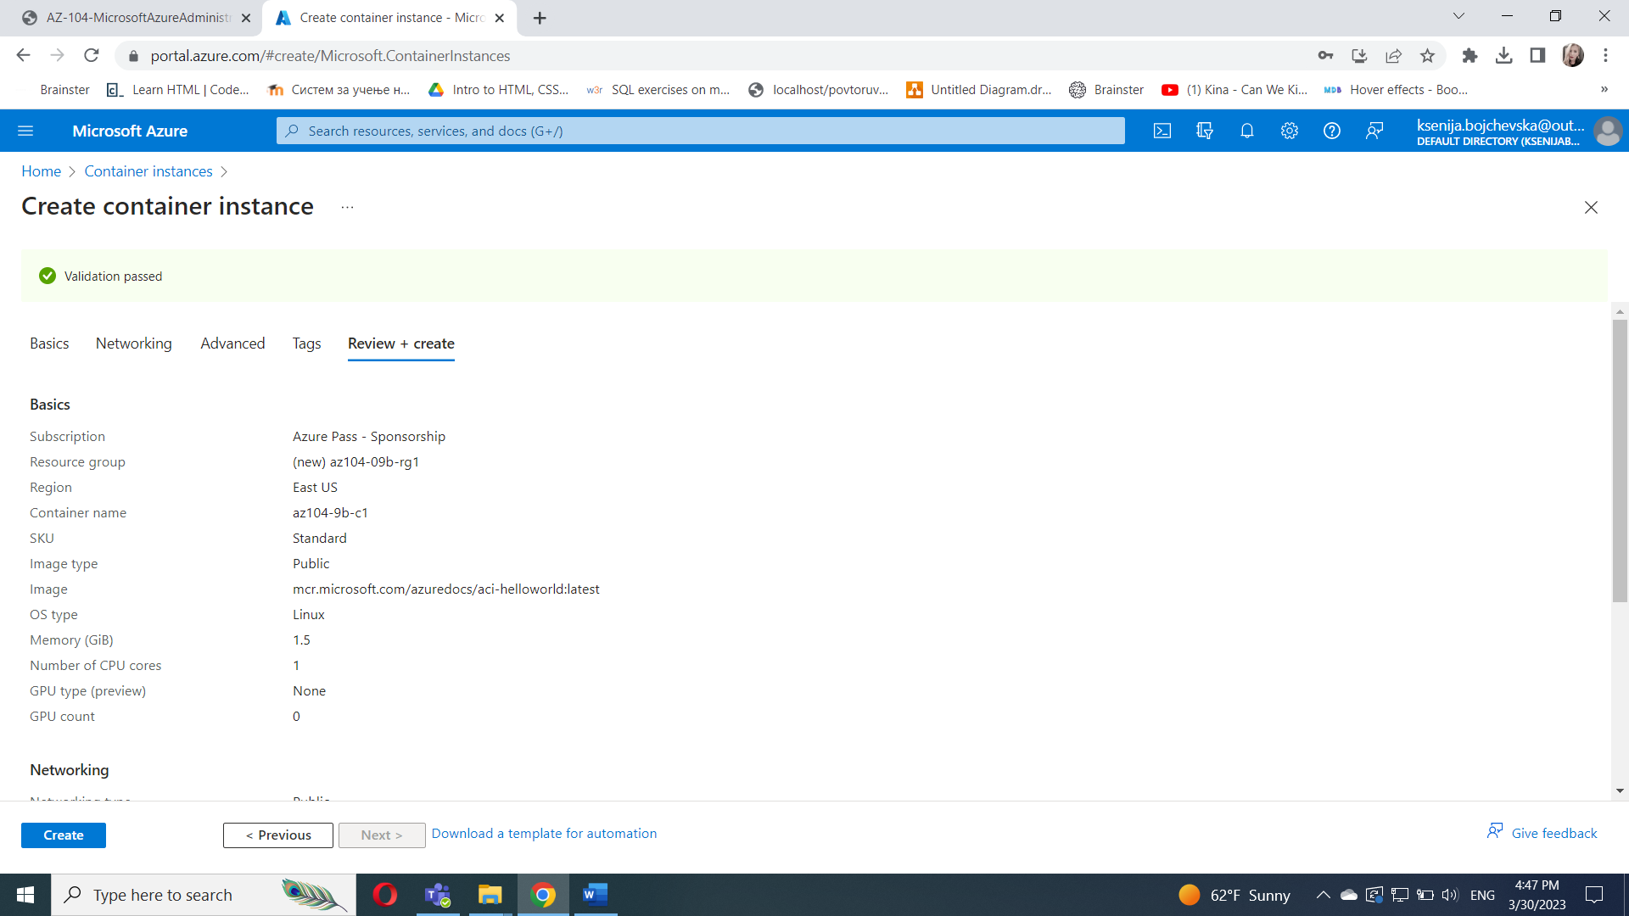

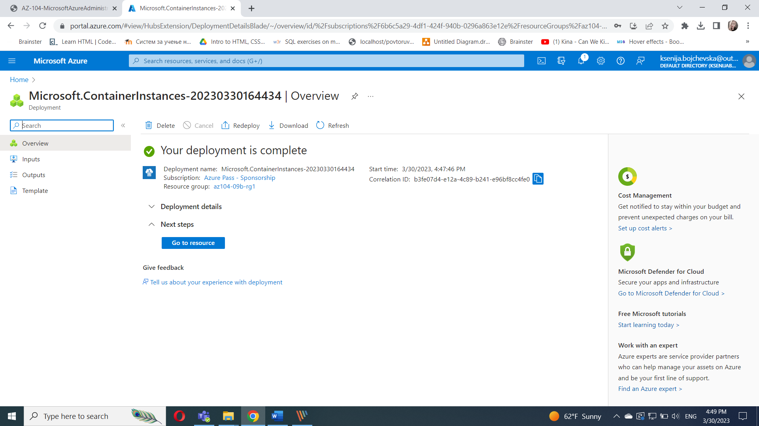

Task 2: Review the functionality of the Azure Container Instance

In this task, you will review the deployment of the container instance.

On the deployment blade, click the **Go to resource** link.

On the **Overview** blade of the container instance, verify that **Status** is reported as **Running**.

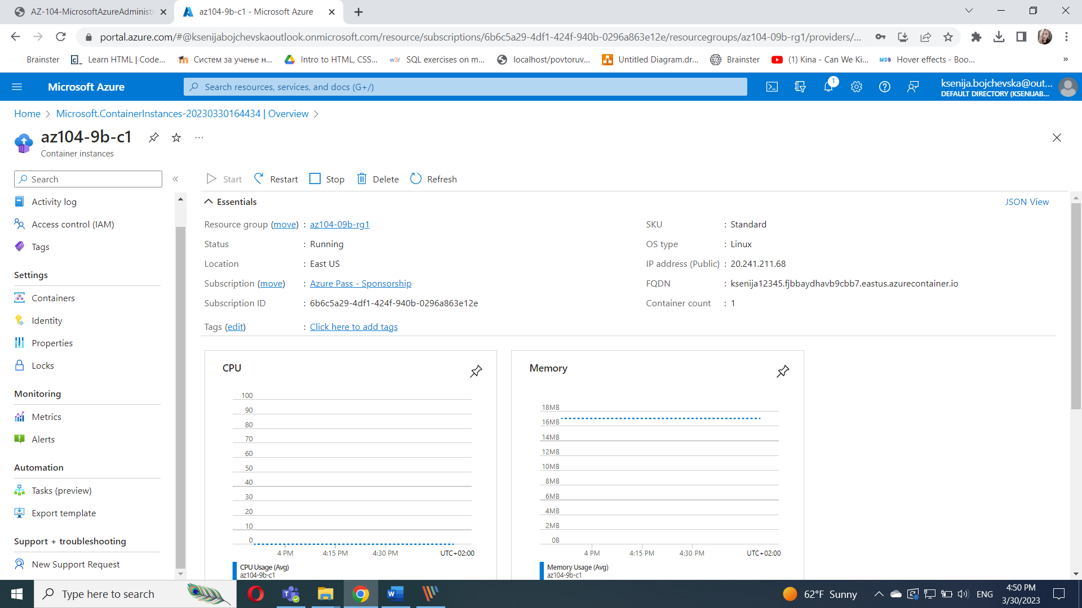

Copy the value of the container instance **FQDN**, open a new browser tab, and navigate to the corresponding URL.

Verify that the **Welcome to Azure Container Instance** page is displayed.

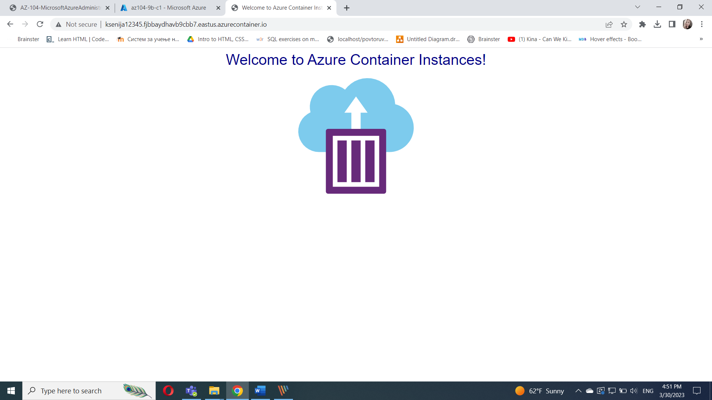

Close the new browser tab, back in the Azure portal, in the **Settings** section of the container instance blade, click **Containers**, and then click **Logs**.

Verify that you see the log entries representing the HTTP GET request generated by displaying the application in the browser.

